Github repository location.

<https://github.com/CGalloway3/CST-135_Bug-Smashers-Final-Project/tree/master/Joint%20submission/Topic%207/vendingmachine>

When a customer walks up to the machine they will be presented with this screen.

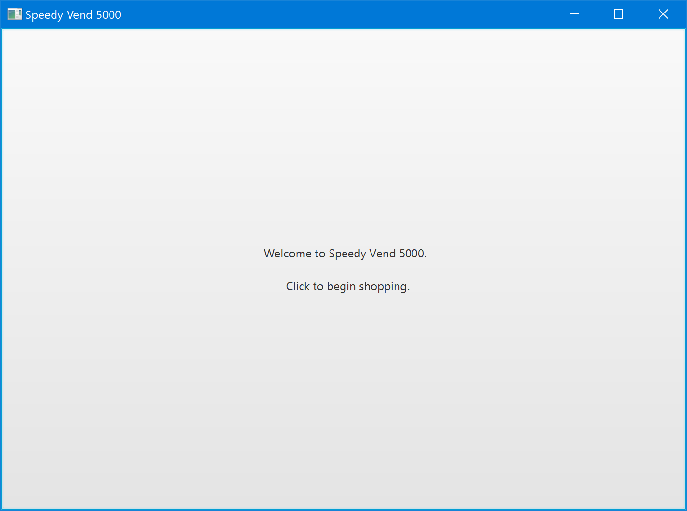

Clicking as instructed will then move them along to the next screen.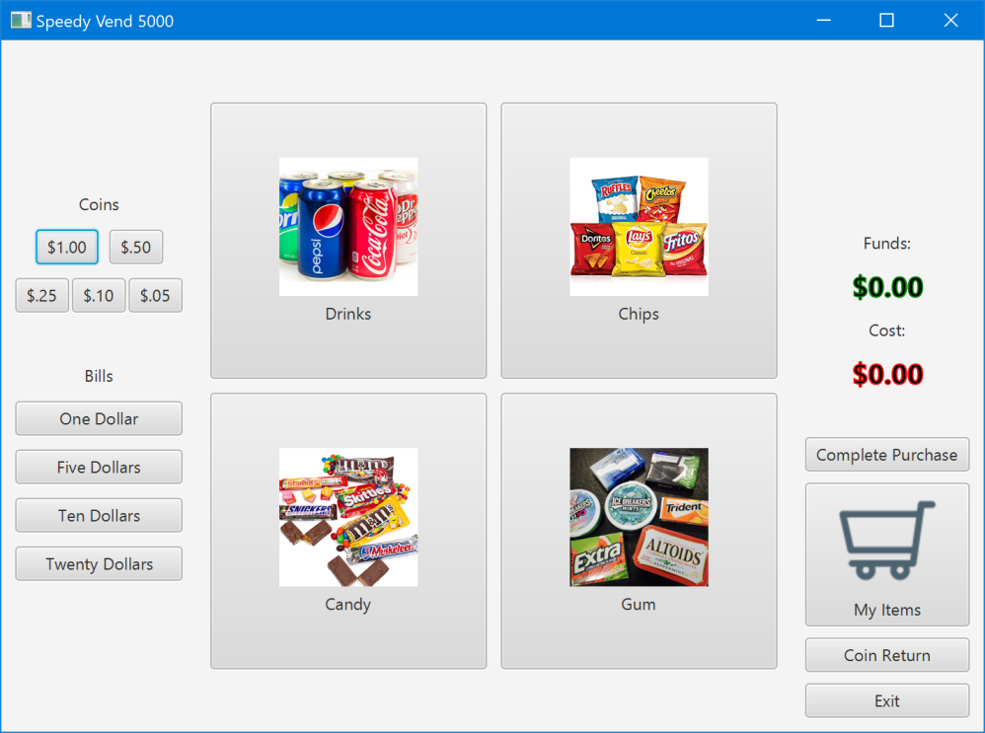

The buttons down the left edge of the screen simulate the inserting of money by the customer, these buttons will be replaced by real money being inserted into the actual machine upon integration of the software into a vending machine unit.

Selecting a category will bring up all the items available in that category.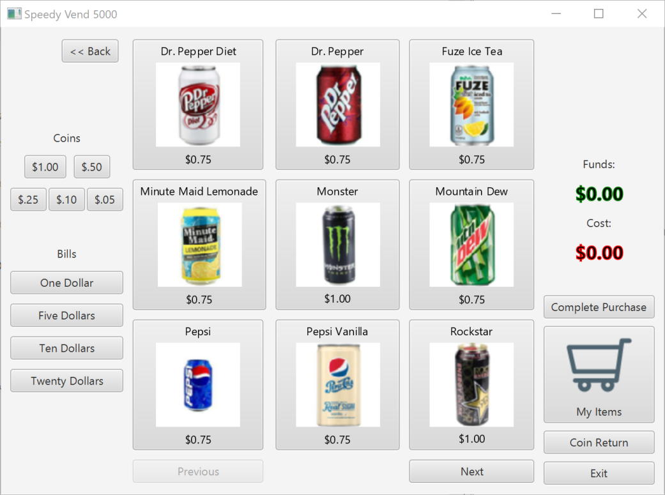

Inventory tracking is fully implemented. The typical user will have no knowledge of the number of any item remaining but items that become out of stock will display as such. (See below. The Pepsi is now out of stock.)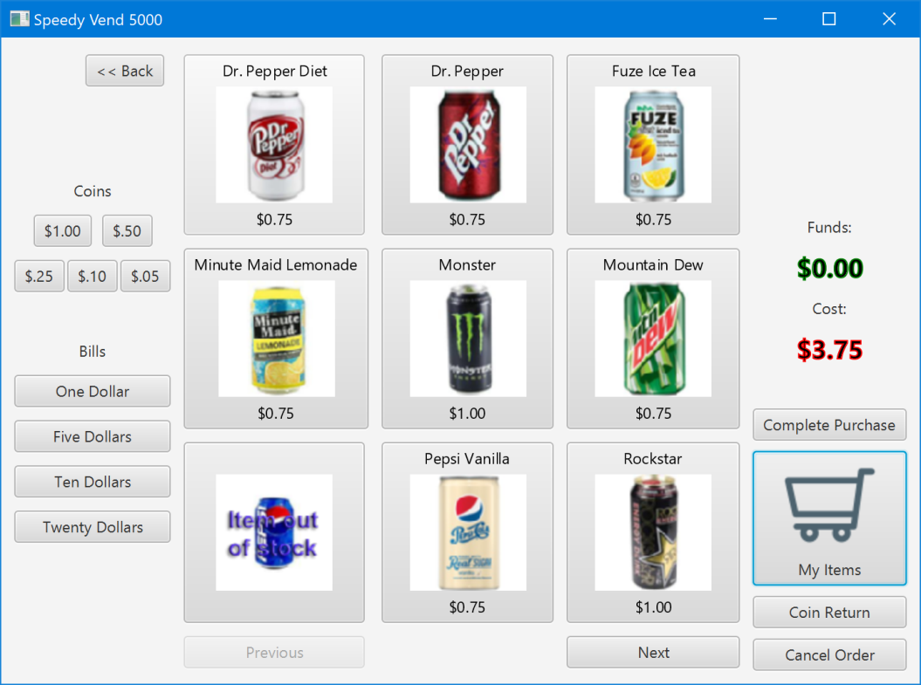

Clicking the My Items button will display a list of all items the customer has selected for purchase

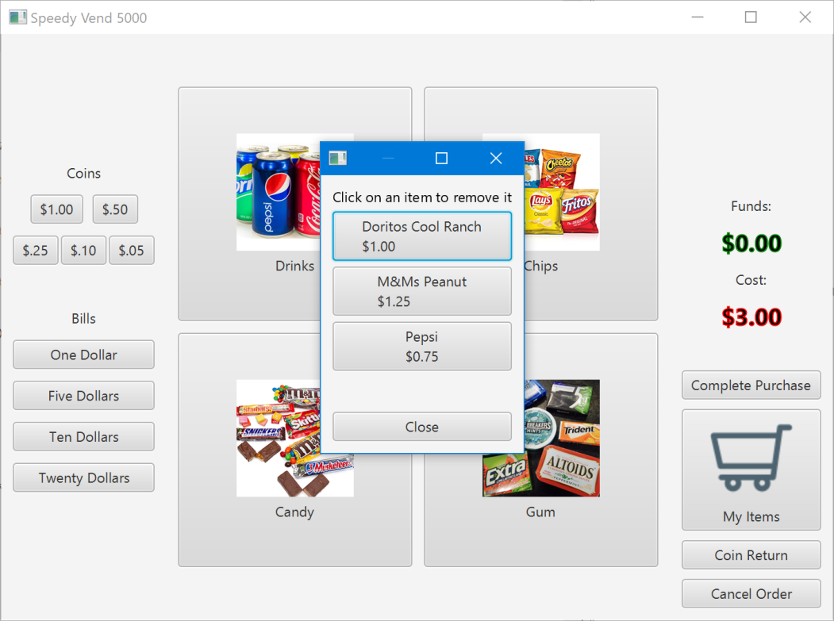

As the window says an item can be clicked on to remove it.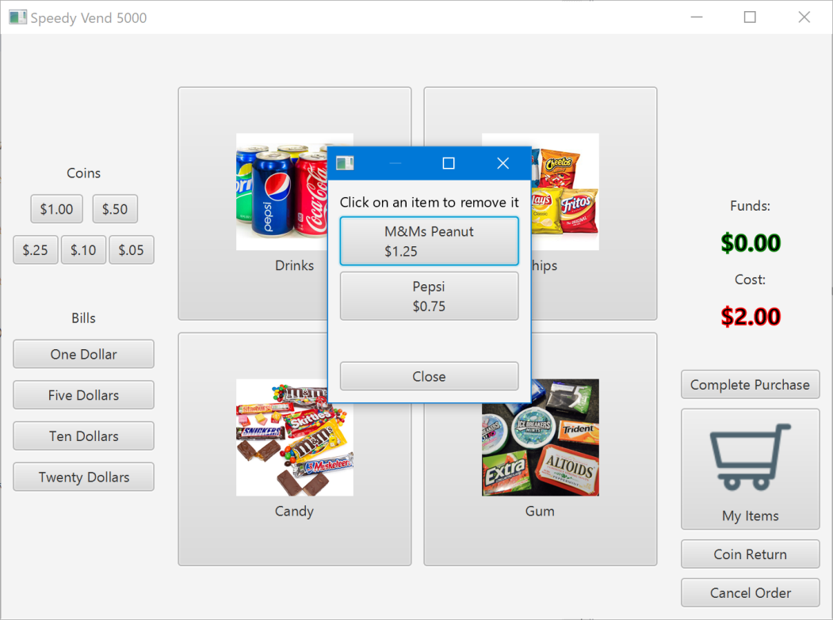

Clicking Complete Purchase brings up a receipt for the customer showing how much their items cost and how much change they were given and exits the customer screen to prepare for the next customer.

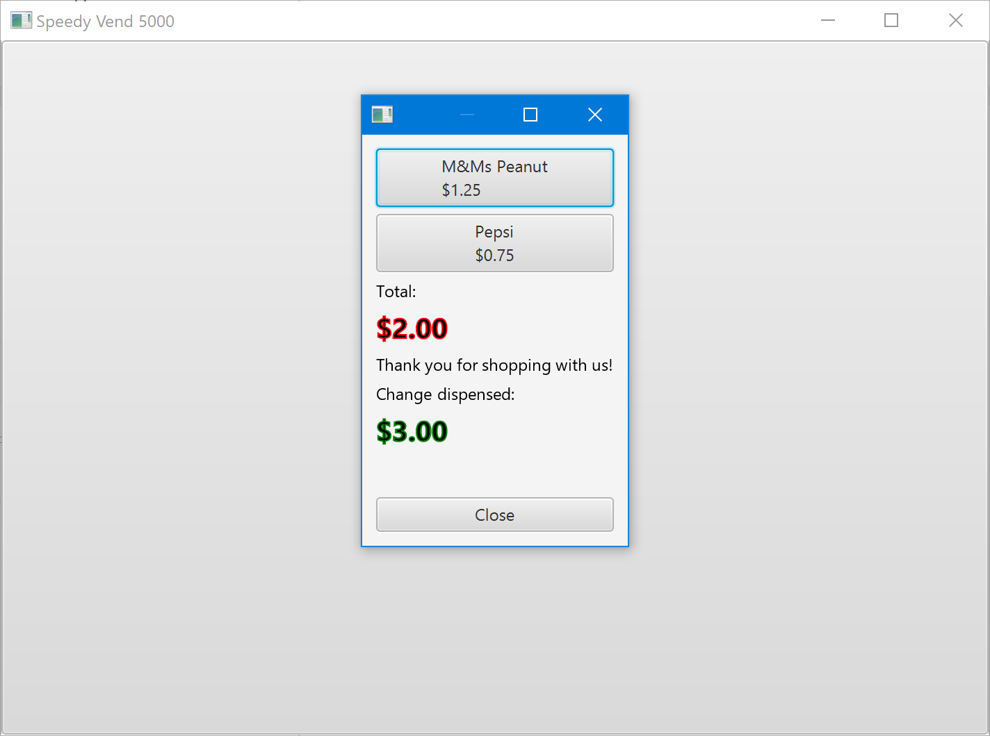

The administration window can be accessed by typing crtl-a on the keyboard before clicking the screen with the mouse and lands the administrator on this page.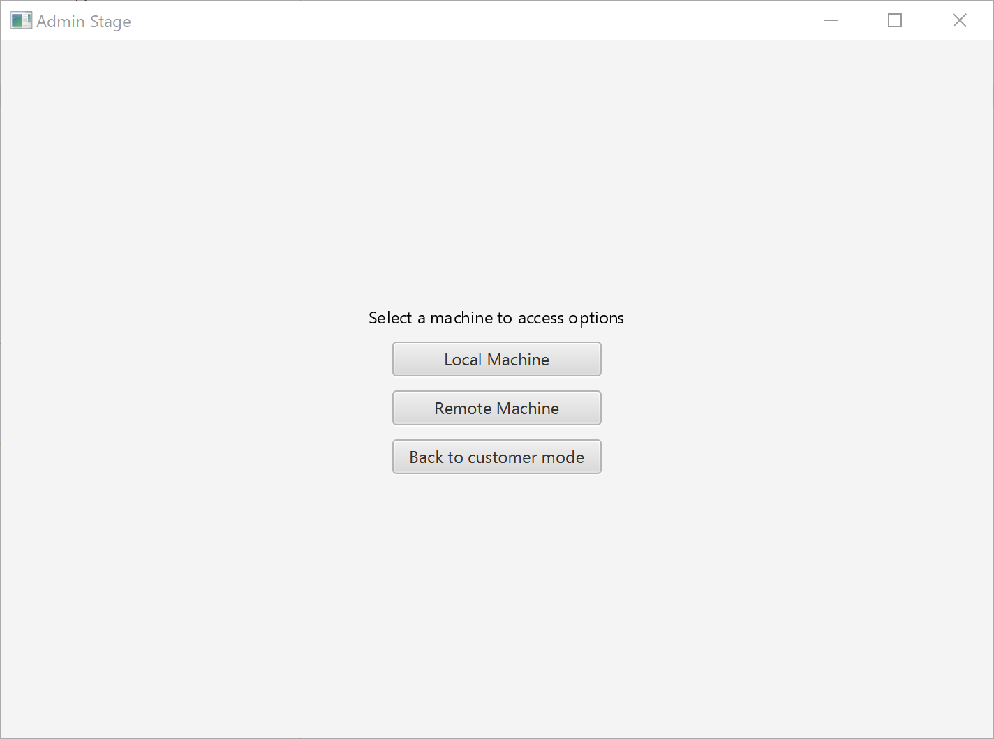

The machine admin can then access local inventory items and view items from other machines. The options available are: search, view in alphabetical order, view by quantity, and view items running low on inventory

.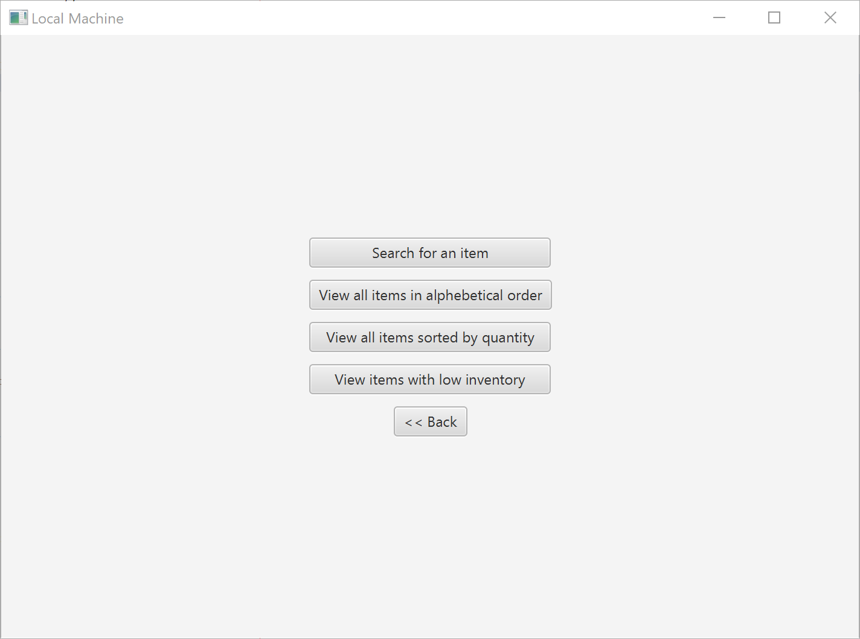

Searching brings up a text entry box.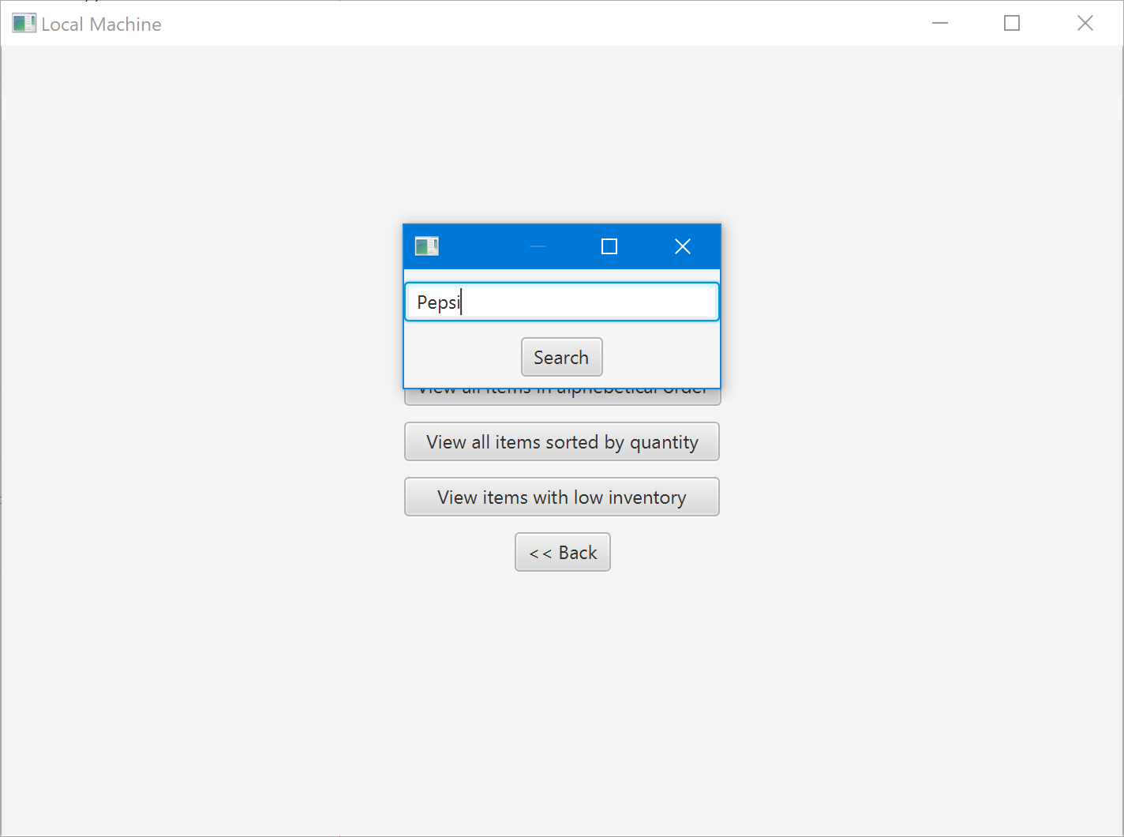

And displays the results.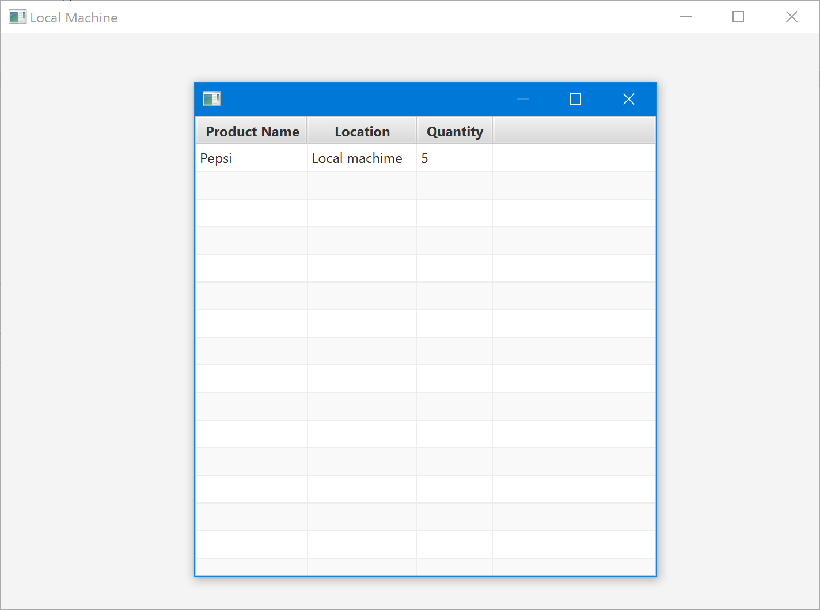

Sorting alphabetically or by quantity brings up a table view of the sorted results.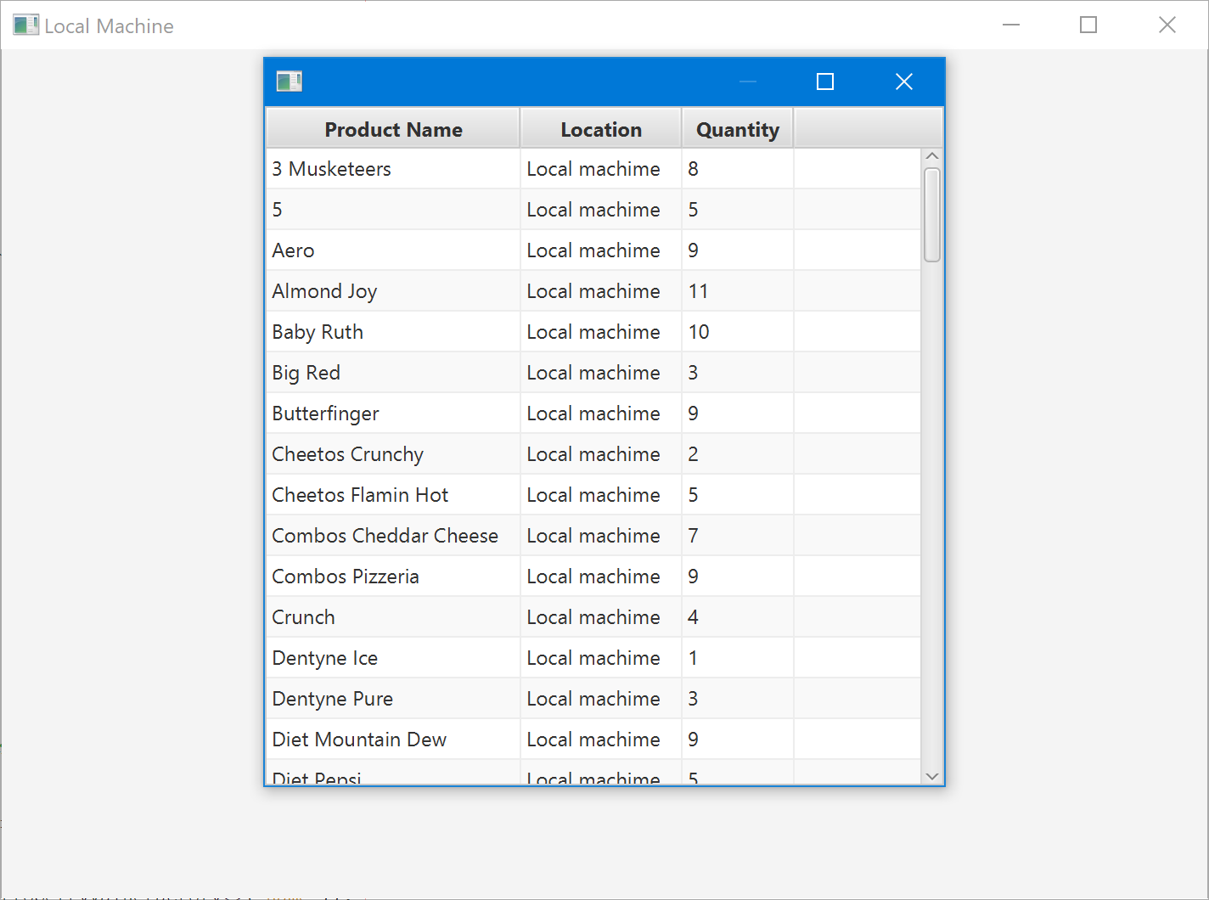

Selecting view items with low inventory brings up another table view with the option to create a purchase order.

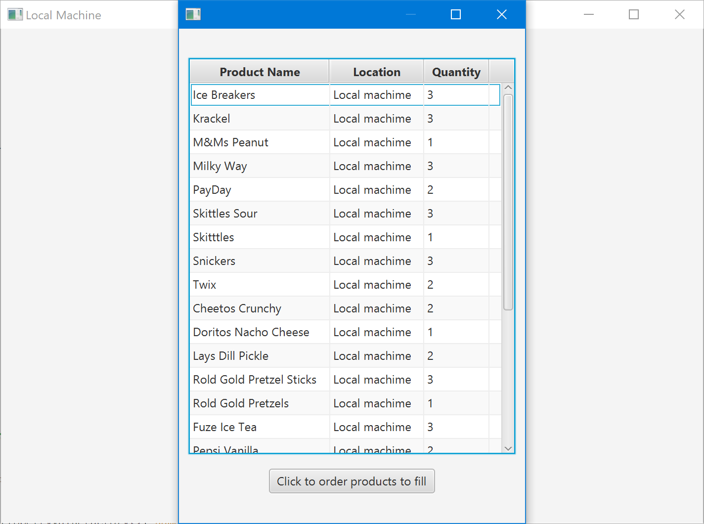

Clicking order products creates a csv file with the products needed to be purchased.

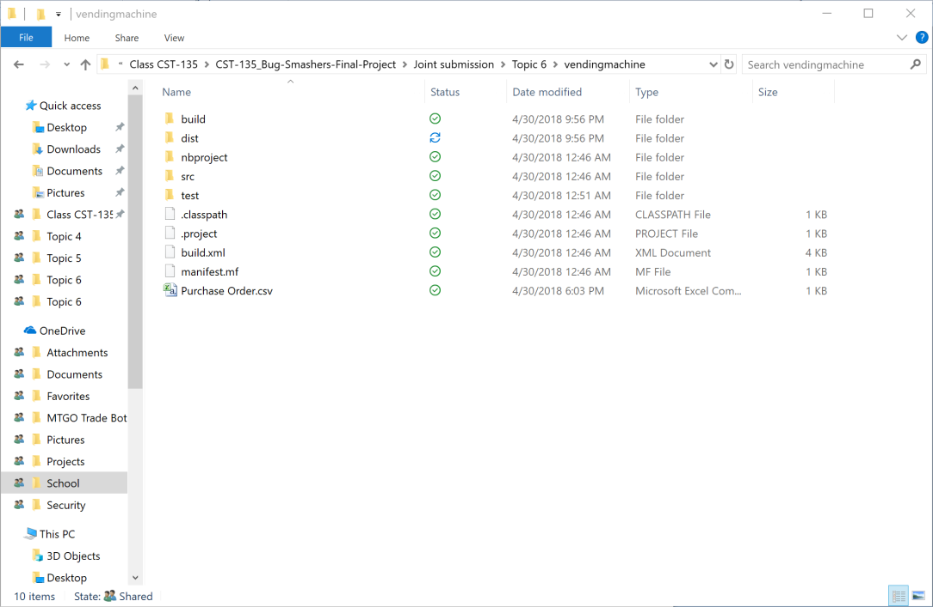

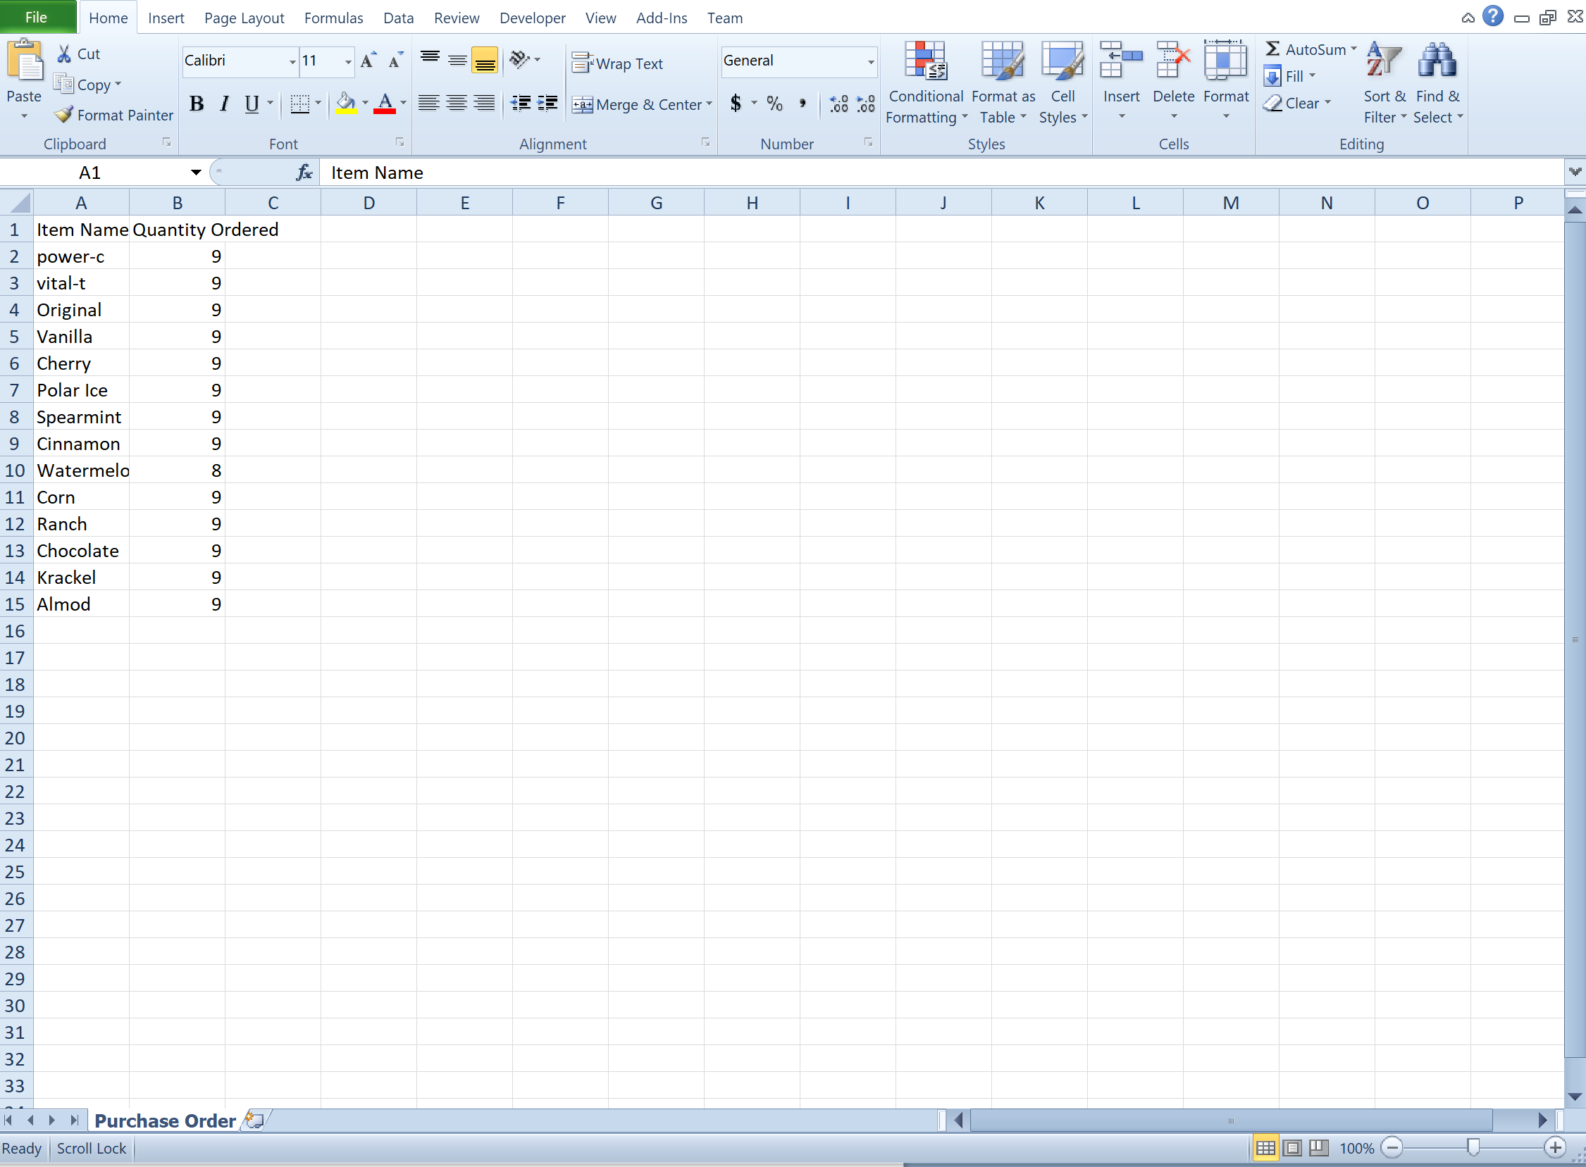

Now from within the admin screen -> Local Machine there is a new option: Process Queue

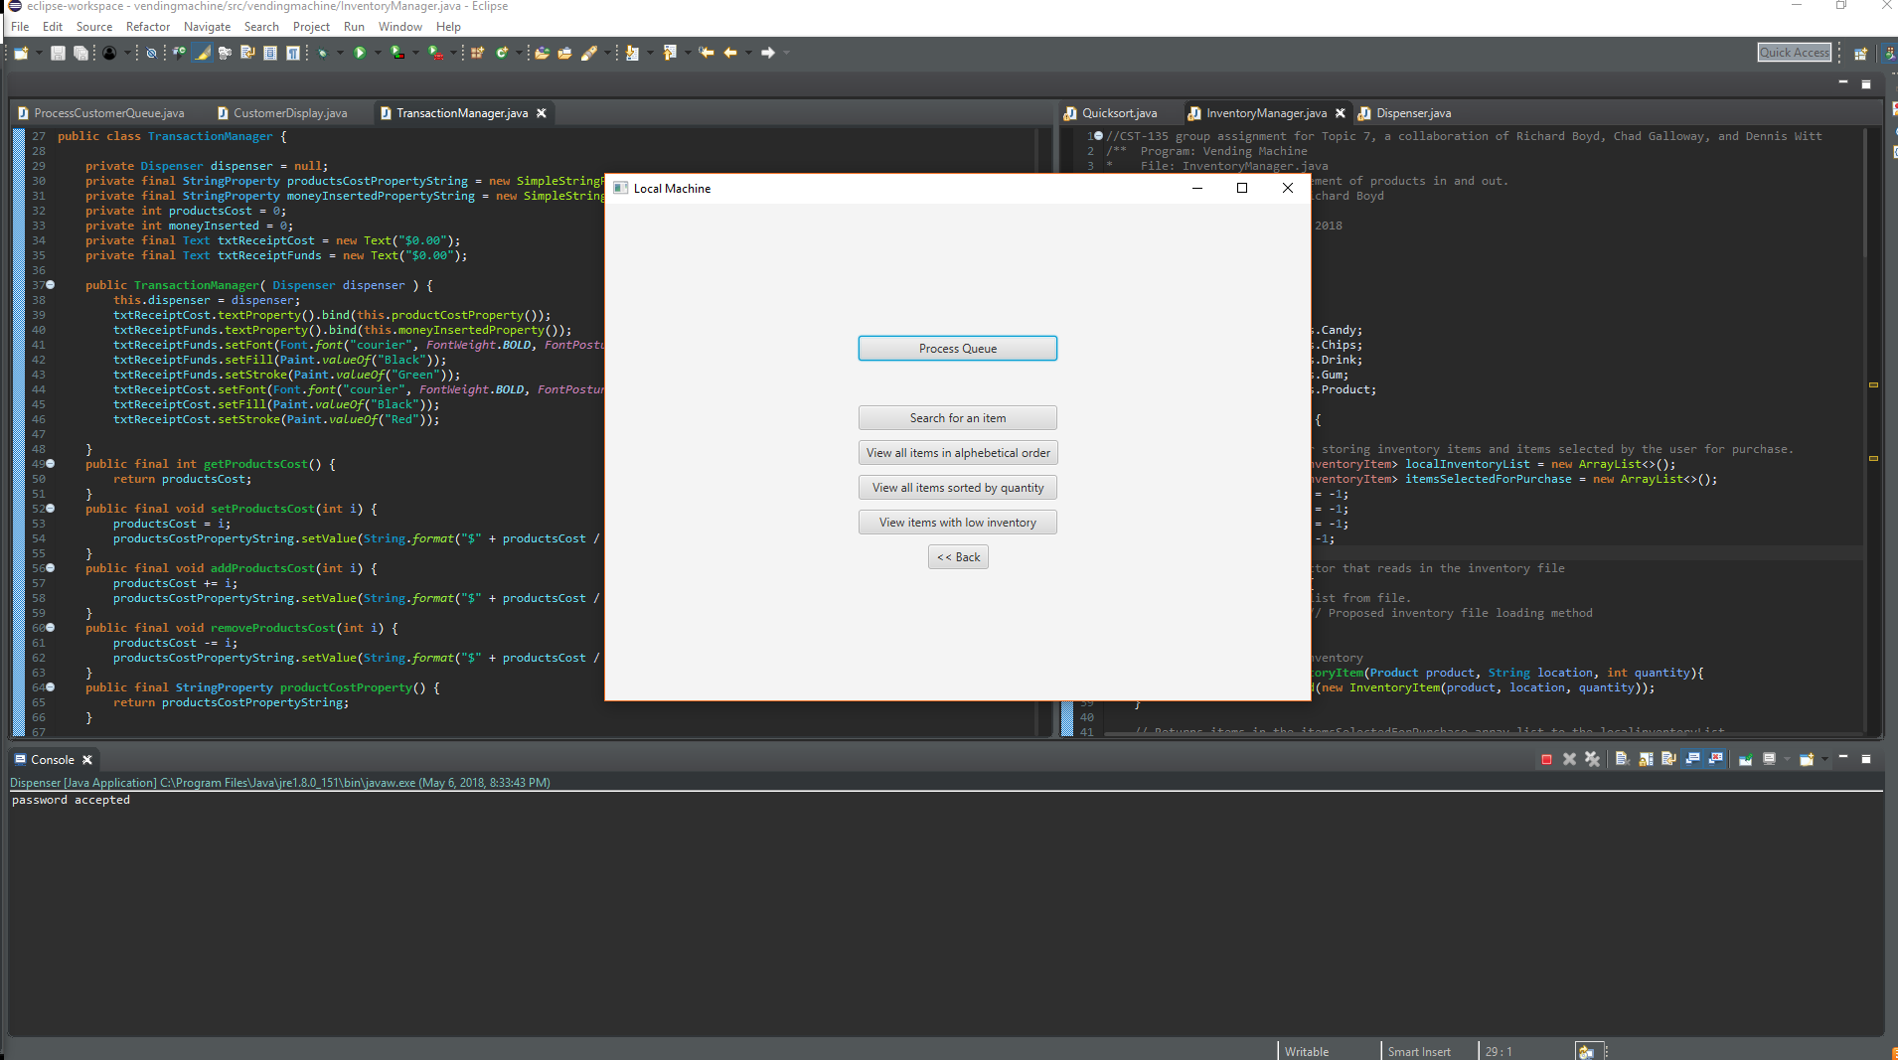

It reads data off a .csv file that contains customer names and the products they desire.

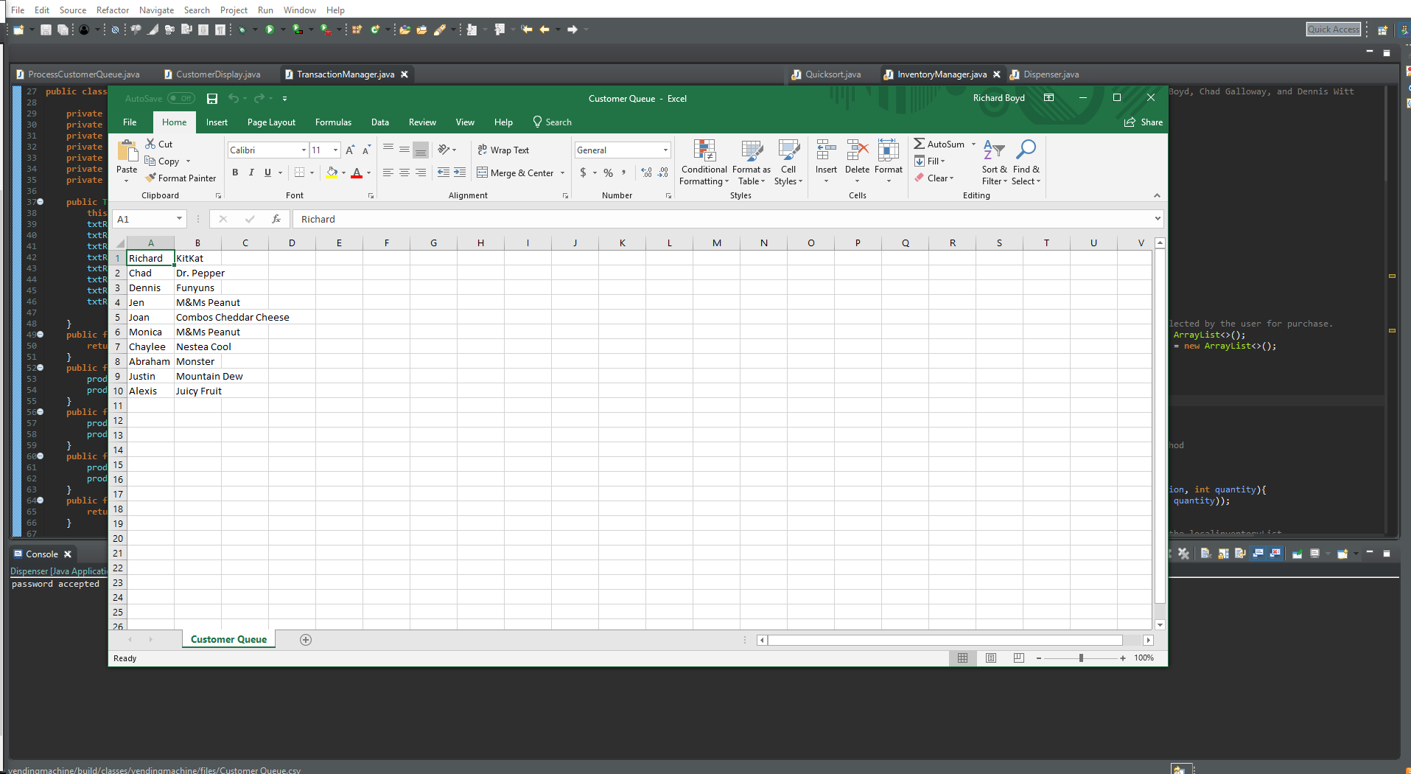

It then displays an animation of people going through the queue and displays all the transactions as they go through.

